This document contains answers to frequently asked technical questions regarding the online application process.

- Question - What do I do when the “Continue” button on the last page of Application process does not allow me to advance to the review page so I can submit the Application?
Answer - The "Description of Position’s Responsibilities" field has a maximum of 500 characters. If your description exceeds 500 characters the continue button does not let you submit your application. Use the "Previous" button on the page (not the browser back button) to navigate back to the "Employer History" page. If the "Description of Position’s Responsibilities" has a red border, you have exceeded the 500 character limit and need to reduce the text to less than 500 characters. Once you shorten the text, the application should allow you to proceed and finish. If you do not see a field with a red border on the "Employer History" page, please check the other pages of your application form to see if there are any fields with a red border and shorten those fields.

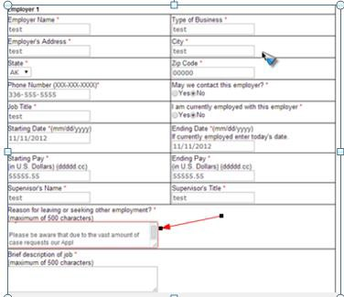

- Question – I’m having trouble opening the Electronic Application link received via email, what should I do?

Answer - Some email systems have HTML turned off in the email settings, so the Electronic Application link does not work as a clickable hyperlink. If you copy and paste the URL you received in your email into the Internet browser and hit the enter key, you should be able to access the Electronic Application. You will need to make sure that the entire link is in the browser field in order to access the Electronic Application which has a unique form ID. If you miss copying any of the characters in the file ID into the browser, you will receive an error message. As seen in the example below, the link sent to you may be on two lines

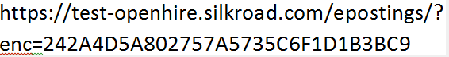

- Question – How do I remove an attachment? I used the delete icon but the attachment is still there?

Answer - When you click the "delete" icon to the left of the attachment (see below) it will remove the file from the system, however the link to the deleted attachment may still be visible. When the employer reviews your application they will view the new file.

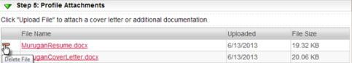

- Question – How do I use my existing profile to apply for multiple jobs?

Answer - To apply using your existing profile, click on the job you are interested in to view the job details. Below the job details, select “Existing Resume/CV” and log into your profile when prompted. Once you have logged in, look at the submittal history where you will see your previous applications and click “Submit this profile” on the right. This will submit your information for your next job application. You may then continue through the form and update information, as needed. After you click “Submit and Continue,” you will receive a confirmation that the application was submitted.

- Question – What do I do if I’m unable to move to “Step 2” of the process after entering profile data when using Internet Explorer version 11?

Answer - This issue is specific to Internet Explorer version 11. If you open up a lower level version of Internet Explorer, Chrome or Firefox, you should be able to complete an application. If you are still unable to complete your application please email hr@mms.org to let us know.

- Question – I’ve created a duplicate profile and cannot see my most recent application when using the “New Resume” option rather than “Existing resume”. What should I do?

Answer - This issue needs to be fixed by a system administrator. Please send an email to hr@mms.org with the ID number of the job for which you applied, along with your name and email address, and a description of the issue you are having. The email address on the old profile can then be changed by the HR team to match the new email address.

- Question – What should I do if I can’t reset the password on my account profile?

Answer - When you try to reset the password and are unable to do so, you may have more than one profile created. If that is the case, the system does not know which profile to reset and you are most likely locked out. When this occurs, contact the employer’s HR team at hr@mms.org with your name and email address and a description of the issue you are having. Someone will change the email address on your old profile to allow you to reset the password. The HR team will then change it back so the accounts are linked.

- Question – What should I do if I receive a “Current Action Temporarily Unavailable” message directly after uploading a resume?

Answer – This typically occurs when your resume file name is either too long, or contains special symbols such as parentheses, asterisks, slashes, etc. If you reduce the file name to less than 14 characters and remove any symbols from the file name, the issue should resolve itself.

We hope that the questions and answers above resolve any technical issues you might experience when applying for a position. If you have a technical question that is not covered above, please send an email to hr@mms.org. In your email please include your name, your email address, the job for which you applied, and a description of the issue you are having, if you are also able to include a screenshot that would be helpful. Someone from the HR team will respond to your email within 2 business days.

Thank you

The MMS HR team

